Arduino 101 Quick Start

# Arduino IDE

1. Go to <https://www.arduino.cc/en/Main/Software> and download the Arduino IDE for your OS. (Arduino 1.6.8 is the preferred version)
2. For Windows, run the downloaded installer.  
   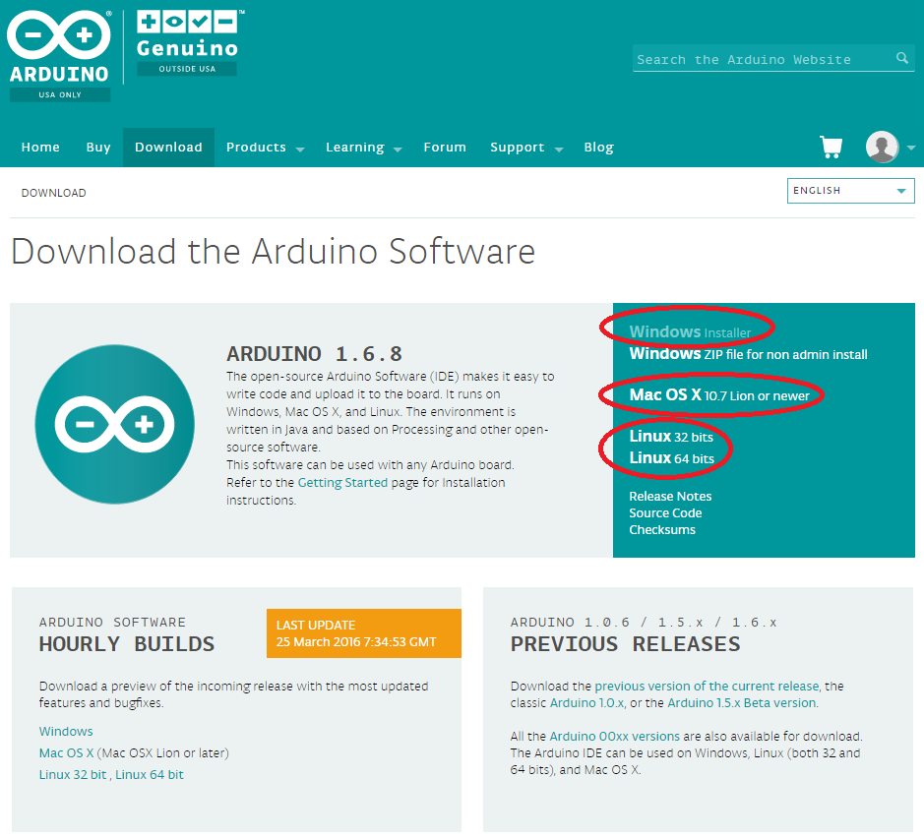

# Install Arduino 101 Core

1. Open the Arduino IDE
2. Go to the **Tools** menu and select **Board Manager**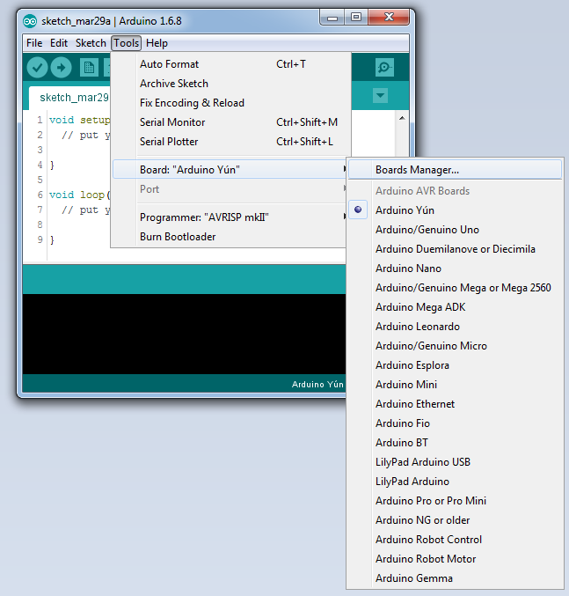
3. Find “Intel Curie Boards” in the platform list and select **Install**.  
   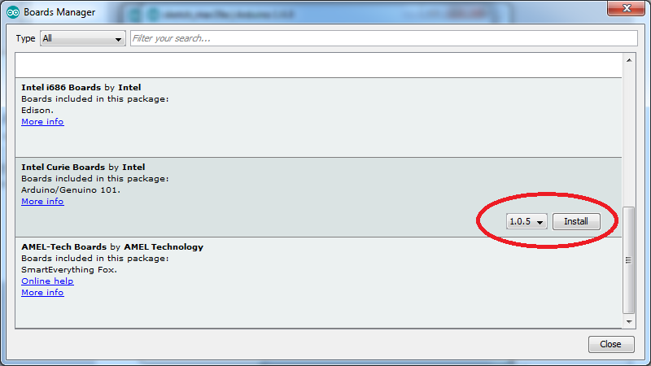
4. You will be prompted three times to accept the Arduino 101 driver installation during this process. Click **Install** for each time.  
   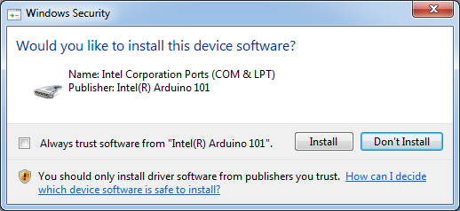
5. Hit **Close** to close Board Manager after the Curie platform has installed.
6. Open the **Tools/Board** menu and select: “Arduino/Genuino 101“  
   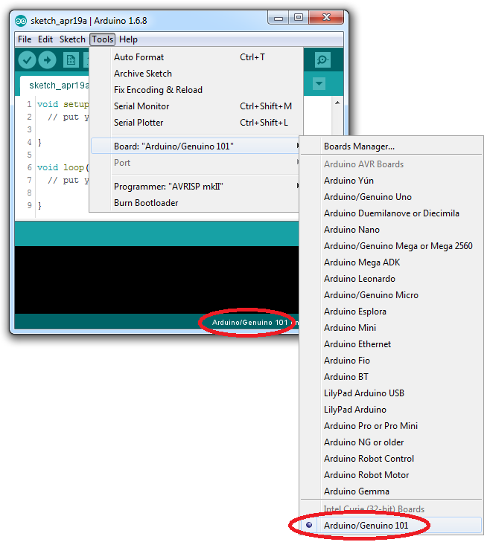
7. If you have not already done so, connect the Arduino 101 to your PC with the USB A-B cable.
8. After about 10 seconds go to the **Tools / Ports** menu. Select the port associated with “Arduino/Genuino 10”.  
   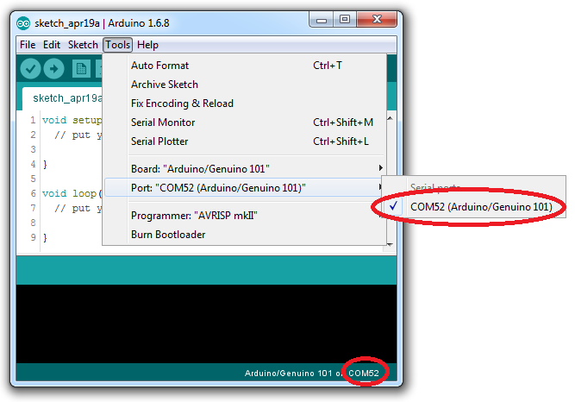

# Run “Blink” Sketch

1. Open the **File / Examples / 01.Basic** menu and select “Blink”  
   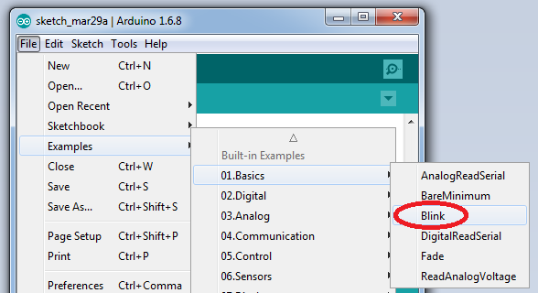
2. Click the Upload menu icon to build and upload the “Blink” sketch to the board.  
   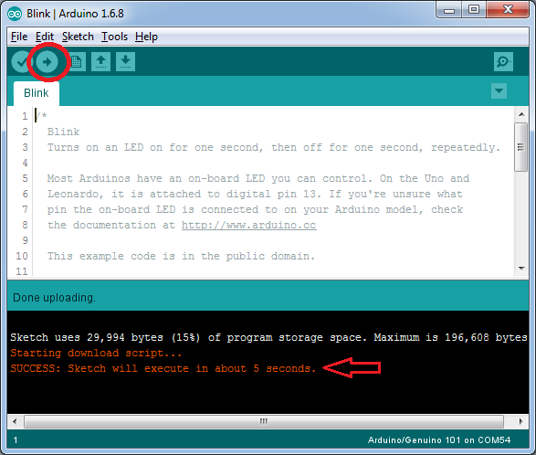  
   If the upload is successful, the console window should display “SUCCESS”. Repeat the process if you experience an error. If it fails again, check your port settings, connection or device driver.